AI-AUGMENTED BACKEND DEVELOPMENT
Title: AI StudyBuddy – AI Assistant for Smarter Learning and Study Support
Project Description:
AI StudyBuddy is an AI-powered learning assistance platform developed to simplify the study process for students by integrating modern web technologies with Generative AI. The system provides an intelligent backend solution that allows users to upload study materials and generate useful learning resources such as summaries, flashcards, quizzes, and personalized study plans. The application is developed using Node.js and Express.js, following a RESTful API architecture that ensures scalability, maintainability, and secure communication between system components. MongoDB is used as the primary NoSQL database, while Mongoose ODM supports schema design, data validation, and efficient database operations. To ensure security, the system implements JWT (JSON Web Token) based authentication along with Role-Based Access Control (RBAC), allowing only authorized users to access protected features. User passwords are securely stored using bcryptjs encryption, preventing unauthorized access. A key feature of AI StudyBuddy is its integration with the Google Gemini AI API, which enables advanced natural language processing. The system dynamically communicates with the AI model to generate high-quality educational content based on the study material provided by the user, making the learning process more efficient and personalized.
Scenario:
Problem
Rahul is a second-year engineering student who struggles to manage large amounts of study material collected from different sources such as notes, textbooks, and online content. Due to limited time and multiple subjects, he finds it difficult to identify important topics and complete revision effectively. Manual preparation of notes and practice materials takes more time, reducing his overall productivity.
Solution
To solve this issue, an AI-based system called AI StudyBuddy is introduced. The platform allows users to upload study materials and automatically generates summaries, quizzes, flashcards, and study plans using Generative AI. The system is developed using Node.js and Express.js, with MongoDB for data storage and JWT for secure access. Integration with the Google Gemini AI API enables intelligent processing of study content.
Impacts
The use of AI StudyBuddy improves the study process by saving time and reducing manual effort. Students can quickly understand key concepts and organize their learning more efficiently. It supports better revision through structured content and helps in managing time effectively, leading to improved learning outcomes.

System Requirements:

To ensure smooth development, deployment, and usage of the AI-STUDYBUDDY AI-Augmented Backend Application, certain system prerequisites must be met.

Software requirements:
Operating System
- Windows 10/11
- macOS
- Linux
Node.js (v18 or above)
Provides a runtime environment for frontend and backend development.
npm (v9 or above)
Package manager used for dependency installation.
Express.js
Backend framework used for API development.
MongoDB Community Server / MongoDB Atlas
NoSQL database used to store:
- User Information
- Chat History
- Documents
- Embeddings
- AI Interactions
- Application Data
MongoDB Atlas Search
Provides full-text search functionality.
MongoDB Atlas Vector Search
Enables semantic search using vector embeddings.
AI Service Provider
- OpenAI API
- Gemini API
- Claude API
- Azure OpenAI (Optional) …etc
LangChain / AI SDK
Used for orchestration of AI workflows.
Browser
- Google Chrome
- Mozilla Firefox
Postman
API Testing
Visual Studio Code
Development Environment
Git & GitHub
Version Control

Hardware Requirements:
Processor
Intel Core i5 (8th Gen+) / AMD Ryzen 5+
RAM
Minimum 8 GB
Recommended 16 GB
Storage
Minimum 5 GB Free Space
Internet Connection
Required for AI API communication
Display
1366 × 768 or above
Architecture:
Technical Architecture:

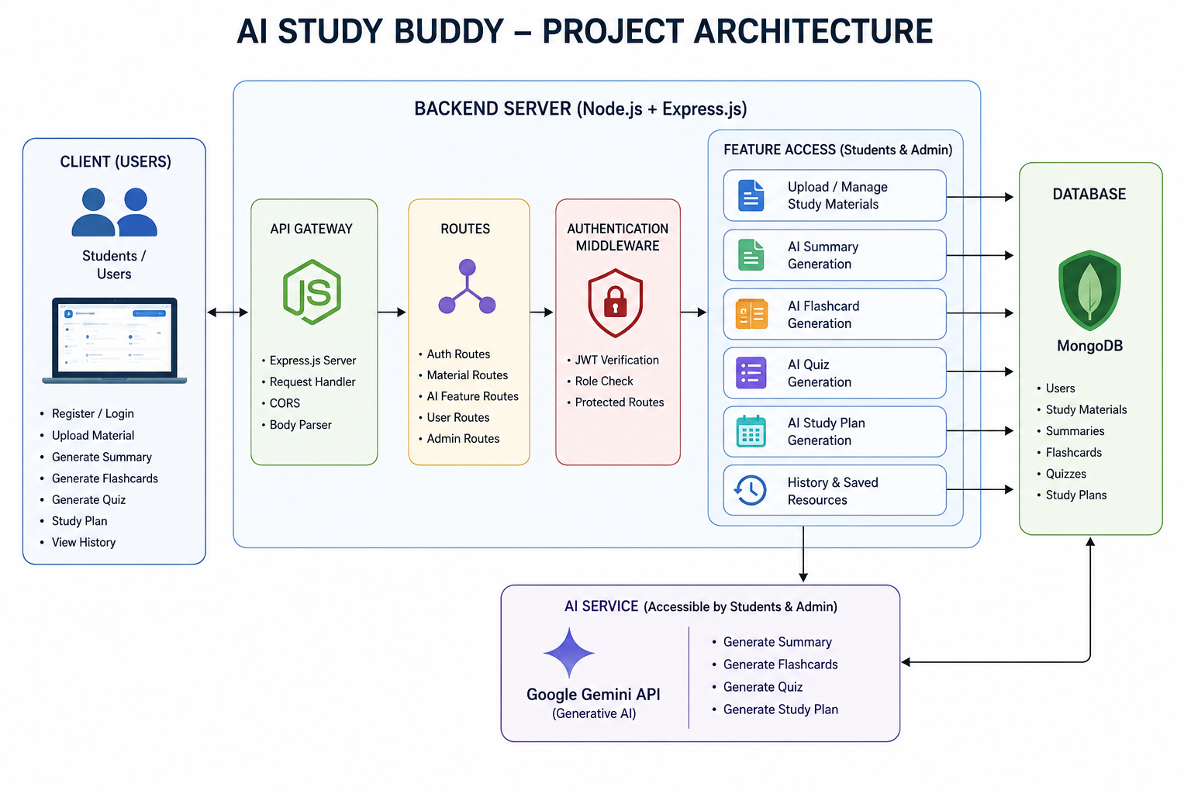

The AI StudyBuddy system follows a modular RESTful architecture designed to provide secure, scalable, and AI-powered learning services. The system processes client requests through the Express.js server, validates users using JWT authentication, interacts with the MongoDB database, and communicates with the Google Gemini AI API to generate intelligent study resources.
The architecture separates authentication, business logic, database operations, and AI processing into independent modules. This separation improves maintainability, scalability, and efficient request handling.
{add screenshots for all backend layer, database layer, ai layer, storage layer, security layer}
Backend Layer
- Node.js
- Express.js
- JWT Authentication
- REST APIs
Database Layer
- MongoDB
- Atlas Search
- Atlas Vector Search
AI Layer
- LLM APIs
- Embedding Models
- RAG Pipeline
- Prompt Engineering
Storage Layer
- MongoDB Collections
- File Upload Storage
Security Layer
- JWT Authentication
- Protected Routes
- Input Validation
- Role-Based Access Control
ER Diagram:


1. User Entity
Stores the details of registered users and administrators.
Attributes:
- _id (Primary Key - ObjectId)
- name (String, Required)
- email (String, Required, Unique)
- password (String, Hashed)
- role (String - Student/Admin)
- createdAt

2. Study Material Entity
Stores study content uploaded by students for AI processing.
Attributes:
- _id (Primary Key)
- userId (Foreign Key → User)
- title
- subject
- content
- createdAt

3. Summary Entity
Stores AI-generated summaries.
Attributes:
- _id (Primary Key)
- userId (Foreign Key → User)
- materialId (Foreign Key → Study Material)
- summary
- createdAt

4. Flashcard Entity
Stores AI-generated flashcards.
Attributes:
- _id (Primary Key)
- userId (Foreign Key → User)
- materialId (Foreign Key → Study Material)
- question
- answer
- createdAt

5. Quiz Entity
Stores AI-generated quizzes.
Attributes:
- _id (Primary Key)
- userId (Foreign Key → User)
- materialId (Foreign Key → Study Material)
- questions
- createdAt

6. Study Plan Entity
Stores personalized study plans generated by AI.
Attributes:
- _id (Primary Key)
- userId (Foreign Key → User)
- studyPlan
- examDate
- createdAt

ER Diagram Explanation
Users can upload documents and interact with AI features. Uploaded documents are processed into vector embeddings and stored in MongoDB. Chat interactions and AI responses are logged for future reference and analytics. Activity logs maintain user actions across the system.
Features
Core Backend Features
- User Registration
- User Login
- JWT Authentication
- Protected Routes
- Middleware
- CRUD API
- File Upload
- Role-Based Access Control
AI Features
- AI Chat Assistant
- Semantic Search
- Vector Search
- Document Question Answering
- Text Summarization
- Content Generator
- RAG (Retrieval Augmented Generation)
- Intelligent Insights
- Natural Language Queries

Roles and Responsibilities
Admin
- Manage Users
- Manage Documents
- Monitor AI Usage
- View Analytics
- Configure System
User
- Register/Login
- Upload Documents
- Ask Questions
- Search Content
- View AI Recommendations
- Manage Personal Data

User Flow:

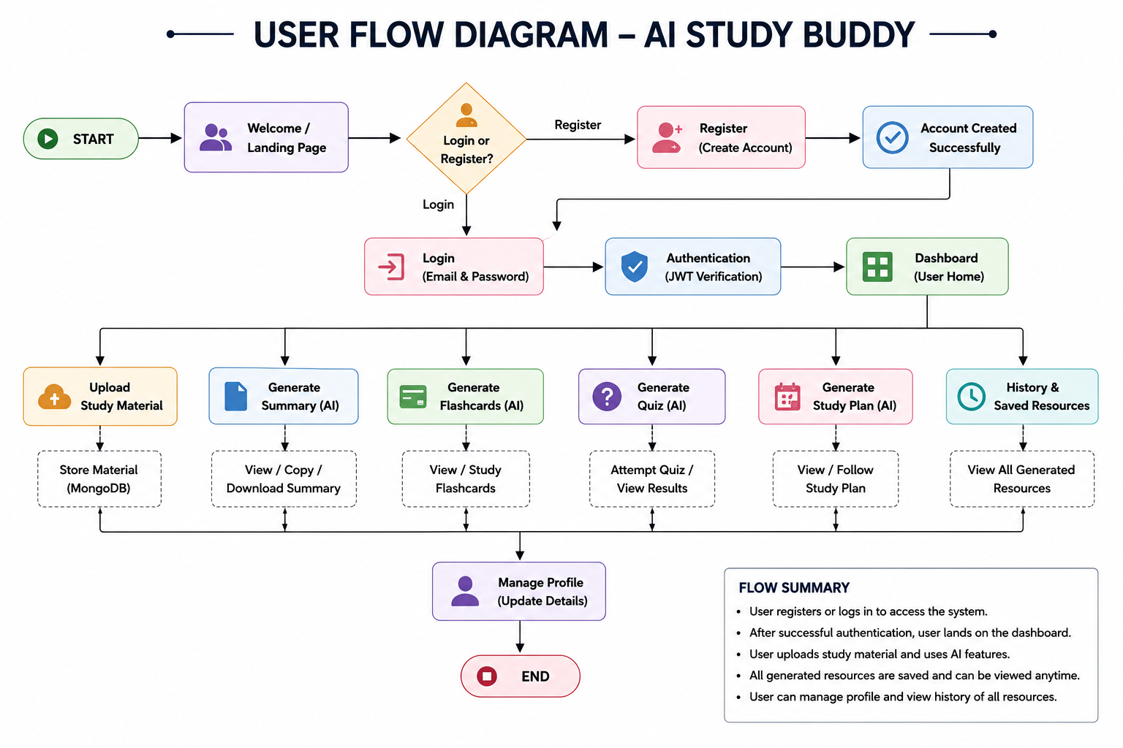

User → Register/Login → JWT Authentication → Upload Study Material → Request AI Feature → Backend Processing → Google Gemini AI API → Data Stored in MongoDB → Response Sent to Client
This architecture ensures secure communication, efficient processing, and reliable performance while supporting future enhancements.
MVC Pattern:
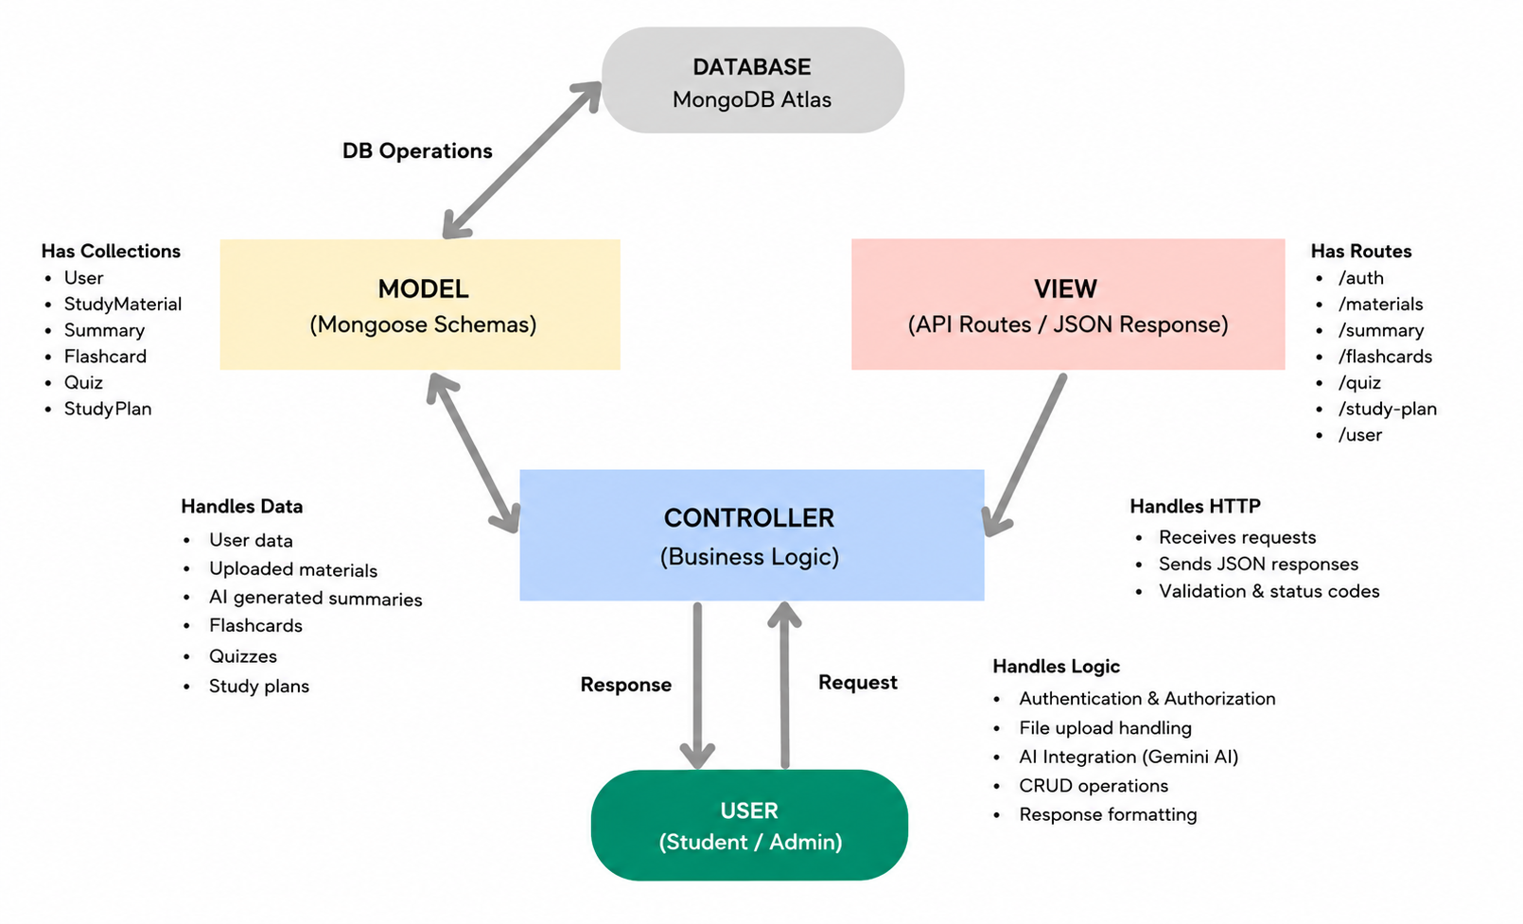
The AI StudyBuddy backend follows the Model-View-Controller (MVC) architecture to organize the application into separate layers, making the code modular, maintainable, and scalable.

Model Layer (Data Layer)
The Model layer defines the MongoDB collections using Mongoose schemas. It is responsible for managing user information, uploaded study materials, and AI-generated learning resources while ensuring data validation and database interactions.

View Layer (API Response Layer)
Since AI StudyBuddy is a backend REST API, there is no traditional user interface in the View layer. Instead, the API returns structured JSON responses to the React frontend, allowing users to interact with the application through REST endpoints.

Controller Layer (Business Logic)
The Controller layer processes incoming API requests, validates user input, performs authentication and authorization, communicates with the database models, invokes the Google Gemini AI service when required, and returns the appropriate response to the client.

Setup & Configuration:
The setup of the AI StudyBuddy backend involves configuring the development environment, installing necessary dependencies, and preparing the system for execution. This process ensures that all components such as the Node.js runtime, Express.js server, MongoDB database, and Google Gemini AI integration work together properly.
Before starting the setup, it is important to ensure that the system meets the required software and hardware specifications. The application supports cross-platform environments including Windows, macOS, and Linux, making it flexible for development and deployment.
Step 1: Install Required Software
- Install Node.js (v16 or above), which provides the runtime environment for executing JavaScript on the server side.
- Install npm (v8 or above), which is used to manage project dependencies and packages.
- Install MongoDB, which acts as the primary NoSQL database for storing user data, study materials, and AI-generated resources.
- Install a code editor such as Visual Studio Code for writing and managing the project files.
- Install Postman or Thunder Client for testing the RESTful APIs of the backend system.
Step 2: Create Project Folder
- Create a new project folder named AI StudyBuddy.
- Open the folder in Visual Studio Code.
- Open the terminal inside the editor to execute commands.
Step 3: Initialize the Project
- Run the following command to initialize the Node.js project
npm init -y

This command creates a package.json file, which stores project details, dependencies, and scripts required for execution.
Step 4: Install Required Dependencies
Install the core backend dependencies using the following command:
npm install express mongoose bcryptjs jsonwebtoken cors dotenv multer @google/genai

These dependencies perform the following functions:
- express → Used to create the backend server and handle routing.
- mongoose → Provides Mongoose ODM for database interaction and schema modeling.
- bcryptjs → Used for encrypting user passwords securely.
- jsonwebtoken → Implements JWT authentication for secure access control.
- cors → Enables cross-origin resource sharing between client and server.
- dotenv → Loads environment variables from the .env file.
- multer → Handles file uploads for study materials.
- @google/genai → Used to integrate the Google Gemini AI API for content generation.

Step 5: Install Development Dependency
Install nodemon for automatic server restart during development:
npm install --save-dev nodemon

This improves development efficiency by automatically restarting the server when changes are made.
Step 6: Create Required Files
Create the following essential files in the project:
- index.js → Main entry point of the application
- .env → Stores environment variables securely
- package.json → Contains project configuration and dependencies
- .gitignore → Specifies files to be ignored in version control
Step 7: Configure Environment Variables
Create a .env file in the root directory and configure the following variables:
PORT=5000
MONGO_URI=your_mongodb_connection_string
JWT_SECRET=your_jwt_secret
GEMINI_API_KEY=your_gemini_api_key

These variables are essential for:
- Running the server on a specific PORT
- Connecting to the MongoDB database
- Securing authentication using JWT_SECRET
- Accessing the Google Gemini AI API
Step 8: Run the Application
- Install all dependencies (if not already installed):
npm install
- Start the backend server:
npm start

Once the server starts successfully:
- The Express.js server begins listening for incoming requests
- The application establishes a connection with MongoDB
- The system becomes ready to process API requests for authentication, study materials, and AI features
Step 9: API Testing
- Use Postman or Thunder Client to test the backend APIs
- Send requests such as registration, login, and AI feature generation
- Verify responses and ensure correct functionality
This setup process ensures that the AI StudyBuddy backend system is fully configured and ready for execution. The proper installation of dependencies, environment configuration, and server initialization enables smooth operation of all system components.
Folder Structure:
The AI StudyBuddy backend follows a modular and well-organized folder structure to ensure clean code management, scalability, and maintainability. The structure separates different functionalities such as routing, business logic, database models, middleware, and utility services into independent directories. This approach makes the application easier to understand, debug, and extend in the future.
The folder structure is designed based on the modular RESTful architecture used in the project, where each component handles a specific responsibility. This separation of concerns improves code readability and allows developers to work on different modules without affecting the entire system.
Project Structure Overview:
AI-Study Buddy/
│
├── controllers/
├── models/
├── routes/
├── middleware/
├── utils/
├── index.js
├── .env
├── package.json
└── .gitignore

Folder Description:
- controllers/
This folder contains the controller logic of the application. Controllers handle incoming requests, process data, and send responses back to the client. They act as the bridge between route handlers and database models. In this project, controllers manage operations such as user authentication, study material handling, and AI feature processing.
- models/
The models folder defines the Mongoose schemas used for interacting with the MongoDB database. Each schema represents a collection such as users, study materials, summaries, flashcards, quizzes, and study plans. These models ensure proper data structure, validation, and consistency within the database.
- routes/
This folder contains all API route definitions. Routes specify the available endpoints for the application, such as authentication APIs, study material APIs, and AI feature APIs. Each route is connected to a corresponding controller function that processes the request.
- middleware/
The middleware folder includes reusable functions that run before the main request processing. It contains components such as authentication middleware, which verifies JWT tokens, and file handling middleware for managing study material uploads. Middleware ensures security and proper request validation.
- utils/
The utils folder contains utility modules that support core functionalities of the system. This includes:
Database connection module for establishing connection with MongoDB
AI integration module for interacting with the Google Gemini AI API
These utilities help keep the code modular and reusable.
- index.js
This is the main entry point of the application. It initializes the Express.js server, loads environment variables using dotenv, connects to MongoDB, registers all routes, and starts the backend server.
- .env
This file stores sensitive configuration data such as MONGO_URI, JWT_SECRET, and GEMINI_API_KEY. It ensures that confidential information is not hardcoded into the application.
- package.json
This file contains project metadata, dependencies, and scripts required to run the application. It is automatically generated during project initialization.
- .gitignore
This file specifies which files and folders should be ignored by version control systems like Git. It typically excludes node_modules and environment files.
Importance of Folder Structure:
The structured organization of the AI StudyBuddy backend provides several advantages:
- Improves code readability and organization
- Supports modular development and scalability
- Simplifies debugging and maintenance
- Enables easy integration of new features
- Promotes clean separation of responsibilities
This modular folder structure ensures that the AI StudyBuddy system remains efficient, scalable, and easy to manage as the project grows.

Backend Development
- Authentication APIs
- JWT Implementation
- AI Service Integration
- Vector Search APIs
- CRUD APIs
- Document Upload APIs
- Chat APIs
Note:
Proper explanation must be provided for every AI API consumed, including:
- Purpose
- Request Structure
- Response Structure
- Cost Considerations
- Security Practices

Database Development
- MongoDB Collections
- Relationships
- Atlas Search Index
- Vector Search Index
- Sample Documents
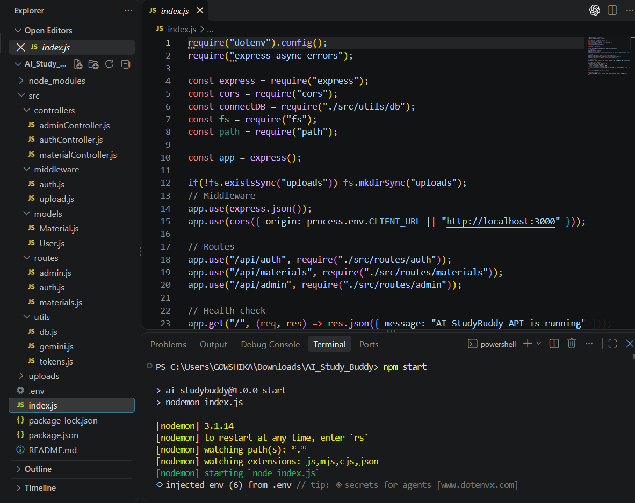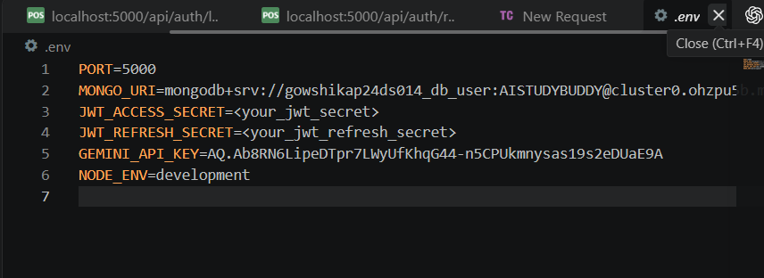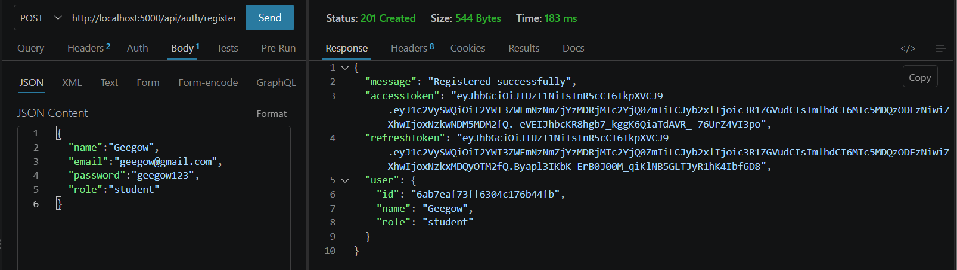
Project Execution:
The execution of the AI StudyBuddy backend involves starting the server, establishing a connection with the MongoDB database, and enabling the system to handle incoming API requests. This process ensures that all backend functionalities such as user authentication, study material management, and AI-powered content generation are operational.
Before running the application, it is essential to ensure that all dependencies are installed, environment variables are properly configured, and the database service is active.
Step 1: Verify Prerequisites
- Ensure that Node.js and npm are installed and properly configured.
- Verify that MongoDB is installed and the database service is running.
- Check that the .env file contains valid values for MONGO_URI, JWT_SECRET, and GEMINI_API_KEY.
Step 2: Install Dependencies
If dependencies are not installed, run the following command:
npm install

This command installs all required packages listed in the package.json file, including Express.js, Mongoose, bcryptjs, jsonwebtoken, and other necessary libraries.
Step 3: Start the Server
Run the following command to start the backend server:
npm start

After executing this command:
- The Express.js server is initialized
- Environment variables are loaded using dotenv
- A connection is established with the MongoDB database
- All API routes are registered and ready to handle requests
Step 4: Server Execution Process
Once the server starts successfully, the following internal operations take place:
- The application listens on the configured PORT (e.g., 5000)
- Incoming requests are processed through middleware such as authentication and validation
- Requests are routed to appropriate controllers for processing
- Controllers interact with MongoDB using Mongoose ODM
- If required, the system communicates with the Google Gemini AI API to generate responses
- Processed data is stored in the database and returned to the client
Step 5: API Testing
After the server is running, the APIs can be tested using tools like Postman or Thunder Client.
Common operations include:
- Registering a new user using authentication APIs
- Logging in and receiving a JWT token
- Uploading study materials for processing
- Requesting AI-generated outputs such as summaries, flashcards, quizzes, and study plans
Each request is validated and processed securely before sending a response.
Step 6: Verify Output
- Check API responses in Postman or Thunder Client
- Verify stored data in MongoDB Compass
- Ensure AI-generated outputs are returned correctly
Execution Outcome
After completing all steps, the AI StudyBuddy backend system becomes fully operational. The system can now handle user requests, process study materials, generate AI-based content, and store results efficiently.

Output Screenshots with Explanation:
- API Testing
- LLM Integration
- AI Chat Interface
- Document Upload
- Search Results
- Recommendation Engine
DEMO VIDEO LINK:
https://drive.google.com/drive/folders/16hpJza0UL-veRFfzVJd2BKRMqT6Wvvi0?usp=drive_link
Source Code Drive Link:
https://drive.google.com/drive/folders/1DjUonAq3UMa3YG4o5UMlS6BSop6MRAEK?usp=drive_link

